**Enum , Structure , Union**

* Enum is a user defined data type which is used to assign names to integral constants.
* Structure is a use defined data type which is used to define items of different data types into single type.
* No data hiding is allowed in structure.
* No functions ,static members, access modifiers ,inside structures.
* Constructors are not allowed in structures.
* Union is a user defined data type where all the member shares same memory location.
* Union is used where we want to save space.
* Only assignment operator is allowed on struct variable.
* Similarities between structure and union

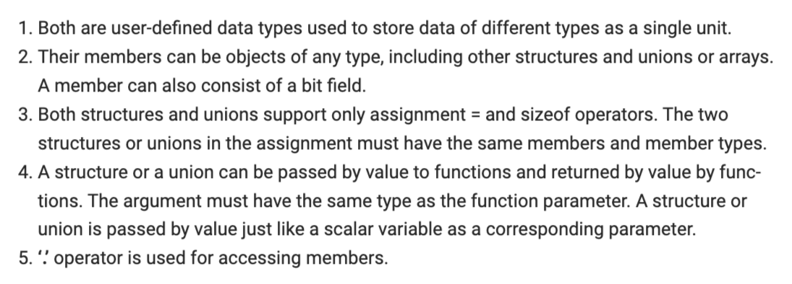

* 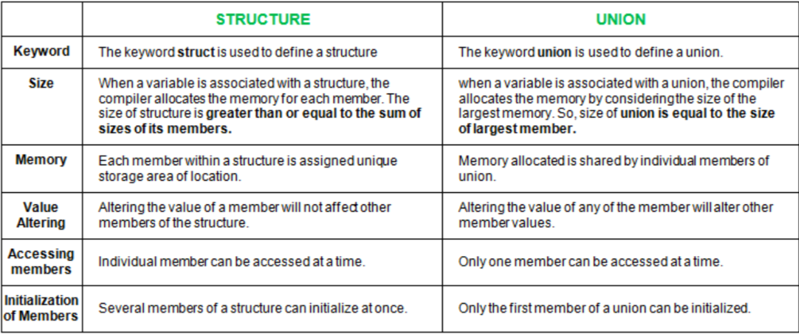
* Structures in C cannot have member functions inside structure but Structures in C++ can have member functions along with data members.
* Anonymous unions/structures are also known as unnamed unions/structures as they don’t have names
* Compound literals - Compound literals feature allows us to create unnamed objects with given list of initialized values.